AI Textbook Q&A System
A RAG-Based Educational Question Answering System
with Deep Source Tracing & ROS 2 Voice Integration

CST8507: Natural Language Processing
Assignment 2 — Final Report

Hye Ran Yoo (041145212)
Peng Wang (041145555)

April 3, 2026
Algonquin College

Table of Contents
1. Abstract
2. Introduction
3. Dataset
4. Method
4.1 Preprocessing Pipeline
4.2 Hybrid Retrieval Architecture
4.3 Deep Source Tracing
5. User Interface
6. Evaluation
7. Part 2: ROS 2 Integration
7.1 Architecture
7.2 Implementation
8. Reproducibility Details
9. Challenges and Solutions
10. Discussion and Future Work
11. References

1. Abstract
This report presents the design, implementation, and evaluation of an AI Textbook Q&A System that leverages Retrieval-Augmented Generation (RAG) to answer educational questions across 46 canonical AI/ML textbooks containing 85,356 text chunks. Our system implements a hybrid retrieval architecture combining four complementary methods: BM25 keyword search (SQLite FTS5), semantic vector search (ChromaDB with all-MiniLM-L6-v2), hierarchical TOC tree navigation, and structured metadata filtering. Results are fused using Reciprocal Rank Fusion (RRF) before answer generation via a local Ollama LLM (qwen2.5:0.5b, ~0.4GB). A key innovation is deep source tracing, which provides pixel-level traceability to the original PDF page and highlighted bounding box region. The system features a Streamlit web interface with an integrated PDF viewer and is extended in Part 2 as a ROS 2 Humble voice-interactive pipeline deployed on an Ubuntu 22.04 loaner laptop.

2. Introduction
Students studying AI and machine learning face a significant challenge: navigating across dozens of textbooks to find relevant information for specific topics. With over 46 textbooks spanning machine learning, natural language processing, computer vision, mathematics, and software engineering, manually searching through thousands of pages is impractical and time-consuming.
This project addresses this problem by building a RAG-based educational Q&A system that enables users to ask natural language questions and receive accurate, sourced answers derived from a curated collection of canonical textbooks. Unlike standard RAG implementations that merely cite book titles, our system provides deep source tracing with clickable references that open the original PDF page with the relevant region highlighted via bounding box coordinates.
Research Question: How can we build a transparent, traceable educational Q&A system for AI/ML learning that provides verifiable answers with pixel-level source tracing?
The system is implemented in two parts: Part 1 focuses on the RAG pipeline with a Streamlit web interface, while Part 2 extends it as a ROS 2 Humble voice-interactive pipeline that enables spoken questions and synthesized speech answers, suitable for robot deployment.

3. Dataset
Our dataset consists of 46 open-access and educational-use AI/ML textbooks, totaling approximately 500MB of PDF documents. The textbooks were processed using MinerU with DocLayout-YOLO to extract text, tables, formulas, and figures while preserving layout information and spatial coordinates. After preprocessing, the dataset yields 85,356 text chunks stored in a SQLite database with corresponding vector embeddings in ChromaDB.
Domain | Books | Examples | Key Topics
Machine Learning | 8 | ISLR, ESL, PRML, PML, Deep Learning | Classification, regression, neural networks
Mathematics | 5 | MML, Convex Optimization, Snell Probability | Linear algebra, optimization, statistics
NLP | 4 | SLP3, Eisenstein NLP, Manning IR | Language models, parsing, information retrieval
Computer Vision | 1 | Szeliski Computer Vision | 3D reconstruction, image processing
Reinforcement Learning | 2 | Sutton & Barto, Hamilton GRL | MDPs, policy gradient, graph RL
Programming | 5+ | Fluent Python, Clean Code, DDIA | Software design, systems, databases
Security / Web | 5+ | Black Hat Python, SRE, SWE | Security, reliability, web engineering
Table 1: Dataset composition by domain (46 textbooks, 85,356 chunks, ~500MB)
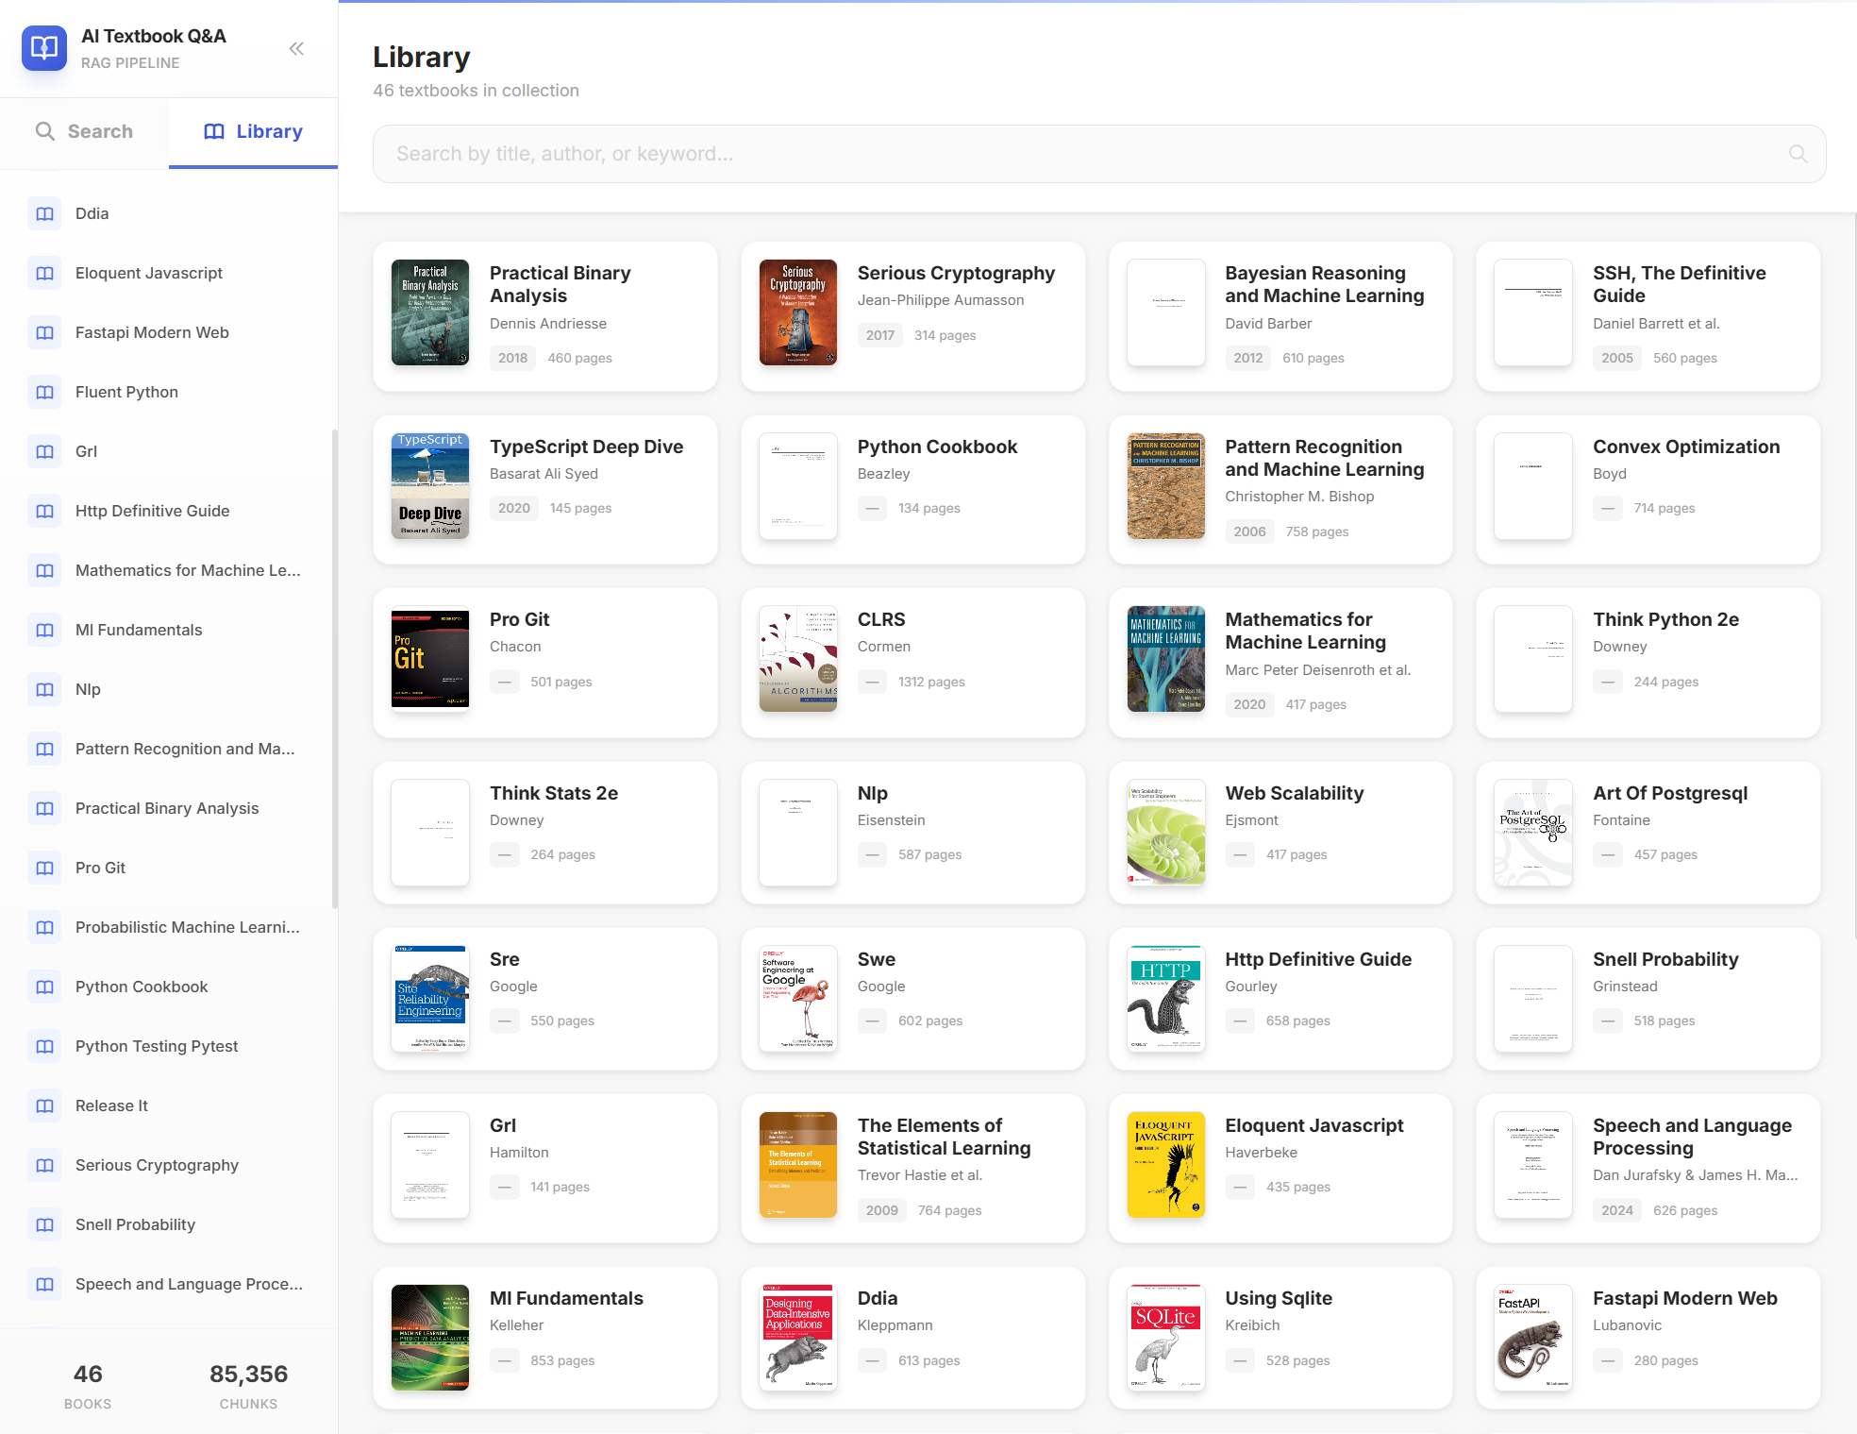
Figure 1: Library View showing all 46 textbooks with cover art, author, and page count

4. Method

4.1 Preprocessing Pipeline
Each PDF textbook is processed through a 5-stage pipeline:
- 1. MinerU + DocLayout-YOLO: Layout analysis detecting 10 element categories (text, title, figure, table, formula, header, footer, caption, reference, equation)
- 2. Text/Table/Formula Extraction: Content is extracted with spatial coordinates (bounding boxes) preserved for each element
- 3. Intelligent Chunking: Text is split into semantically meaningful chunks using section boundaries with metadata (book, chapter, page, content type)
- 4. Dual Indexing: Each chunk is indexed in both SQLite FTS5 (for keyword search) and ChromaDB (for semantic vector search using all-MiniLM-L6-v2 embeddings)
- 5. TOC Tree Construction: Hierarchical table-of-contents trees are built for each book to enable structured navigation and LLM-guided retrieval

4.2 Hybrid Retrieval Architecture
Our system employs a 4-method hybrid retrieval architecture, each method contributing unique strengths to maximize recall and precision:
Method | Technology | Description
1. BM25 Keyword | SQLite FTS5 | Fast exact keyword matching using TF-IDF-like scoring
2. Semantic Vector | ChromaDB + MiniLM | Embedding-based similarity using all-MiniLM-L6-v2 (384-dim)
3. TOC Tree | LLM Reasoning | Hierarchical TOC navigation using LLM to identify relevant sections
4. Metadata Filter | Structured Query | Filtering by book title, chapter, page number, content type
Table 2: Four retrieval methods in the hybrid architecture
Results from all four methods are combined using Reciprocal Rank Fusion (RRF), which produces a unified ranking by computing: RRF_score(d) = sum(1 / (k + rank_i(d))) for each document d across all methods i, where k=60 is the smoothing constant. This fused ranking is then passed to the Ollama LLM (qwen2.5:0.5b, ~0.4GB memory footprint) to generate a contextual answer.

4.3 Deep Source Tracing
A key innovation of our system is deep source tracing. Unlike standard RAG systems that only cite book titles, our approach stores bounding box coordinates (x1, y1, x2, y2) for each text chunk extracted during preprocessing. When a user clicks "View PDF" on a search result, the system opens an inline PDF viewer at the exact page with the source region highlighted in yellow. This enables instant visual verification against the original source material, ensuring transparency and academic integrity.

5. User Interface
The system provides a Streamlit-based web interface running at http://localhost:5173, featuring:
- Search Interface: Natural language query input with 4 retrieval method toggles, adjustable top-K sources slider (1-20), and library collection filter for selecting specific textbooks
- System Answer: AI-generated response with related topic tag suggestions for follow-up exploration
- Source Documents: Ranked list of retrieved chunks with book title, chapter, page number, section heading, relevance score, and a "View PDF" button
- PDF Viewer: Inline document viewer with page navigation, zoom controls, one-page/two-page modes, full-screen mode, and highlighted source region overlay
- Library Tab: Browse all 46 textbooks with cover art, author, year, and page count

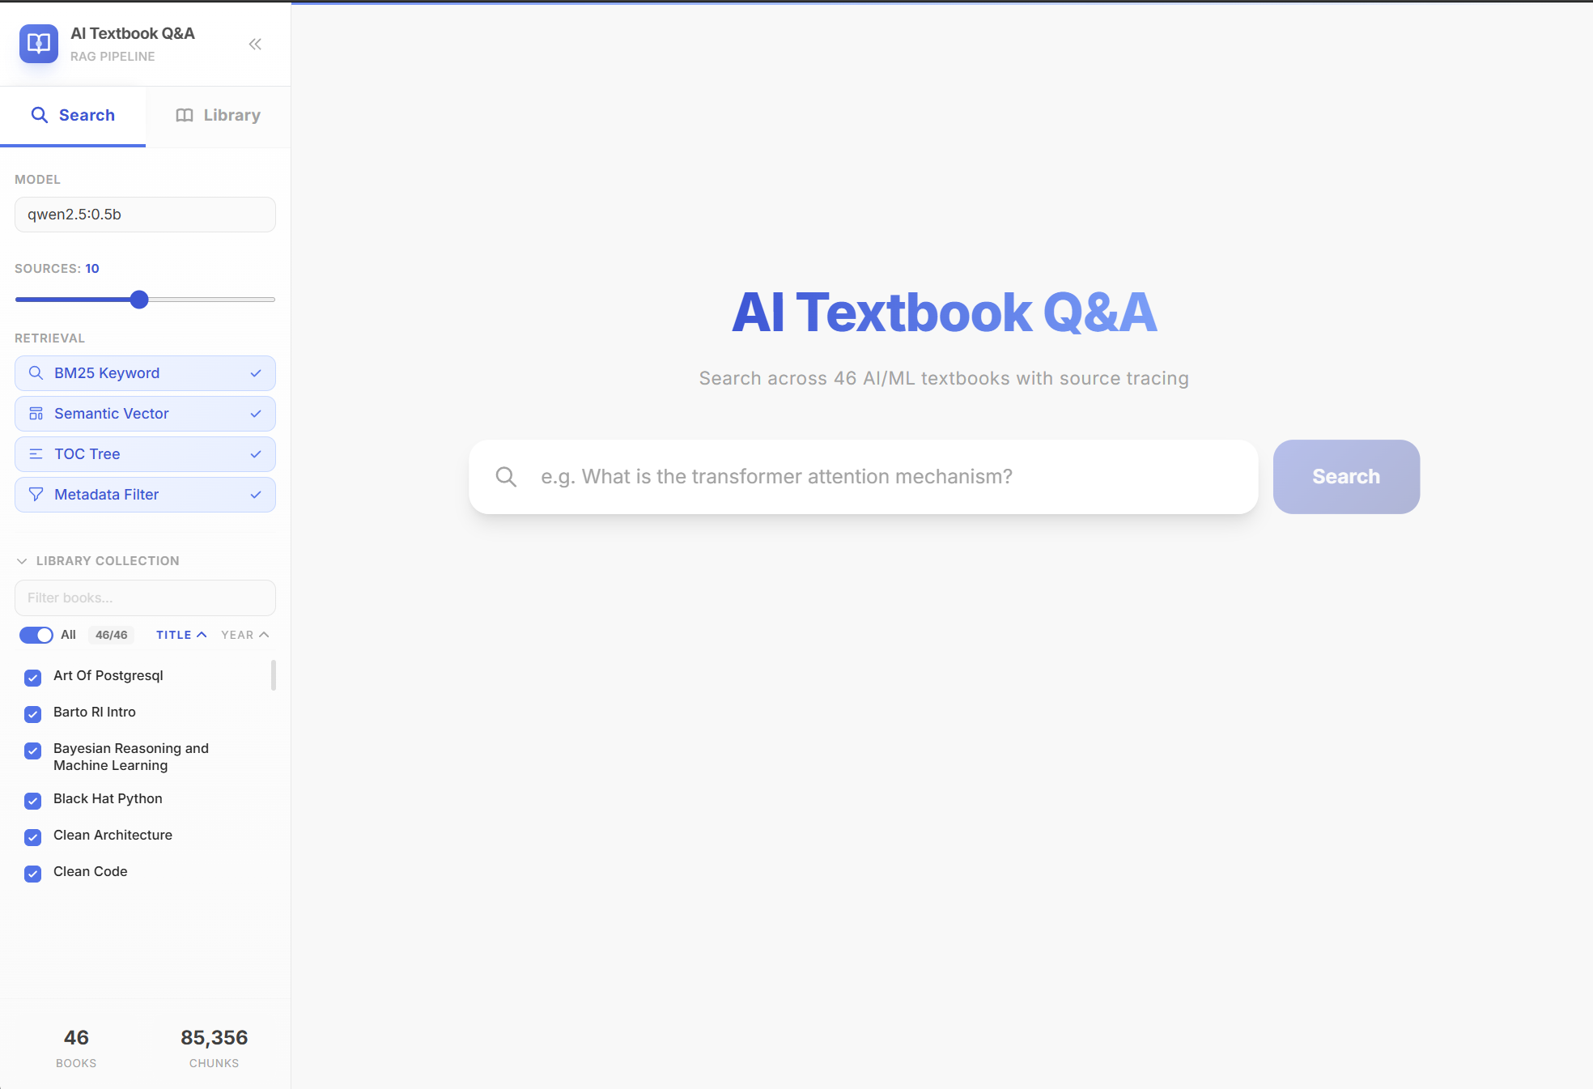
Figure 2: Search interface with model selector, 4 retrieval toggles, source slider, and library filter
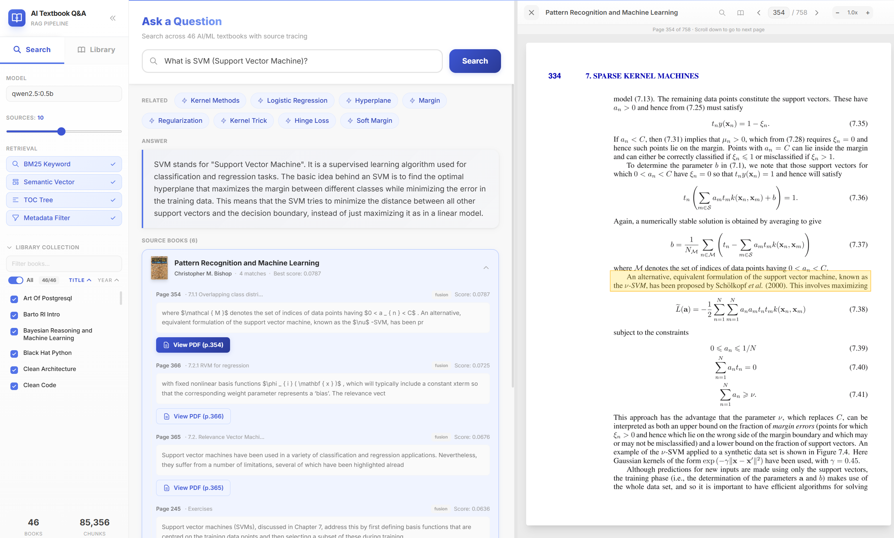
Figure 3: Search results for "What is SVM?" showing RAG answer, related topics, source books with relevance scores, and inline PDF viewer (Pattern Recognition and Machine Learning, p.354)

6. Evaluation
To evaluate system performance, we prepared 20 test questions spanning multiple AI/ML domains. Each question was run through the system and manually assessed using the following scoring criteria:
Score | Meaning
1.0 | Correct - Answer fully addresses the question with relevant sources
0.5 | Partially Correct - Answer partially addresses the question
0.0 | Incorrect - Answer does not address the question
Table 3: Scoring criteria for manual evaluation

6.1 Test Questions
# | Question | Domain | Score
1 | What is neural attention? | Deep Learning
2 | What is the difference between generative and discriminative classifiers? | ML
3 | What is the gradient for logistic regression? | ML / Math
4 | What is an N-gram language model? | NLP
5 | What is skip-gram in Word2Vec? | NLP
6 | How do RNNs work as language models? | Deep Learning
7 | What is a 3D rigid body transformation? | CV / Math
8 | Why is weight initialization important in deep learning? | Deep Learning
9 | What is network depth in neural networks? | Deep Learning
10 | What is cost-sensitive classification? | ML
11 | What is TF-IDF? | NLP / IR
12 | What is backpropagation? | Deep Learning
13 | What is the Transformer architecture? | NLP / DL
14 | What is Word2Vec? | NLP
15 | What is Named Entity Recognition? | NLP
16 | What is beam search? | NLP
17 | What is dropout regularization? | Deep Learning
18 | What is batch normalization? | Deep Learning
19 | What is transfer learning? | ML / DL
20 | What is the BLEU score? | NLP
Table 4: 20 evaluation questions across AI/ML/NLP domains (Score column: fill after testing)
For each question, the top 3 retrieved documents are listed and marked for relevance. The final accuracy score is calculated as the mean score across all 20 questions. Target accuracy: >80%.

7. Part 2: ROS 2 Integration

7.1 Architecture
The RAG pipeline is extended into a voice-interactive system using ROS 2 Humble on Ubuntu 22.04. The system consists of 5 ROS 2 nodes communicating via topics and services:
Node | Package | Input | Output
1. RecordingPublisher | aisd_hearing | Microphone + Silero VAD | /recording topic
2. WordsPublisher | aisd_hearing | /recording | /words topic (Whisper STT)
3. OllamaPublisher | aisd_hearing | /words | /ollama_reply topic (RAG + LLM)
4. SpeakClient | aisd_hearing | /ollama_reply | /speak service call
5. SpeakService | aisd_speaking | /speak service | Audio output (gTTS)
Table 5: ROS 2 pipeline nodes and their communication flow
The pipeline flow is: Voice Input -> Silero VAD -> Whisper STT -> RAG + Ollama LLM -> gTTS -> Speaker Output. All 5 nodes run concurrently in a tmux session with labeled panes for real-time monitoring.

7.2 Implementation
The key contribution is ollama_publisher.py, a new ROS 2 node that bridges Part 1 (RAG) and Part 2 (ROS 2). It subscribes to the /words topic (Whisper output), loads a knowledge.txt file at startup, constructs a system prompt with RAG context, queries the local Ollama API (localhost:11434) using qwen2.5:0.5b, and publishes the response to /ollama_reply. A 15-second cooldown timer prevents the system from processing its own TTS output (echo loop). Custom hallucination filtering checks for repetition patterns, known Whisper artifacts, and trigram analysis before forwarding input to the LLM.
Deployment is automated via start_loaner.bat which: (1) SCP syncs source files to the laptop, (2) kills any existing tmux session, (3) runs colcon build --symlink-install, and (4) launches 5 tmux panes with labeled node identifiers (e.g., "[1/5 MICROPHONE]").
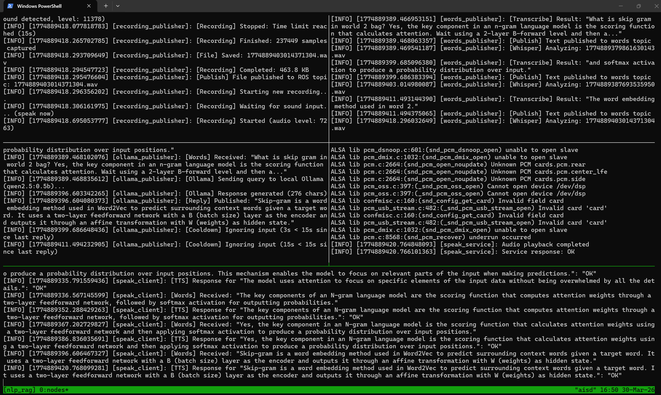
Figure 4: ROS 2 tmux session showing all 5 nodes in operation - voice input to speech output pipeline

8. Reproducibility Details

Platform and System Setup
- Part 1 (RAG + Web UI):
- - OS: Windows 11 with Python 3.10+
- - Backend: FastAPI server on port 8000
- - Frontend: Streamlit (Vite-based) on port 5173
- - Database: SQLite FTS5 + ChromaDB
- - LLM: Ollama with qwen2.5:0.5b (localhost:11434)
- Part 2 (ROS 2 Voice Pipeline):
- - OS: Ubuntu 22.04 (loaner laptop)
- - ROS 2: Humble Hawksbill
- - STT: faster-whisper (int8 quantization)
- - TTS: gTTS (Google Text-to-Speech)
- - VAD: Silero VAD for voice activity detection

Execution Steps
Part 1: pip install -r requirements.txt && ollama pull qwen2.5:0.5b && python backend/main.py (start API) && cd frontend && npm run dev (start UI)
Part 2: Run start_loaner.bat from Windows to deploy and launch on the laptop

Source Code
GitHub: github.com/LannieYoo/nlp_project
Key files: backend/main.py, frontend/src/*, ros2/ollama_publisher.py, ros2/knowledge.txt, ros2/run_loaner.sh

9. Challenges and Solutions
Challenge | Problem | Solution
Whisper Hallucinations | Whisper generates phantom text on silence or background noise. | Implemented Silero VAD pre-filtering + custom hallucination detector with repetition checking, known artifact phrase matching, and trigram frequency analysis.
Echo Loop (TTS to Mic) | The microphone picks up the TTS audio output, creating an infinite feedback loop. | Added a 15-second cooldown timer after each LLM reply publication, during which all incoming Whisper transcriptions are ignored.
Resource Constraints | Three AI models (Whisper, Ollama, gTTS) must run simultaneously on a single CPU laptop. | Selected qwen2.5:0.5b (0.4GB) for LLM and faster-whisper with int8 quantization. Total memory footprint stays under 1.5GB, meeting the assignment requirement.
Cross-Platform Deployment | Development on Windows but deployment target is Ubuntu 22.04 laptop. | Created automated batch/shell scripts: SCP file sync, colcon build, and tmux session management. One-click deployment via start_loaner.bat from Windows.
Complex PDF Layout Parsing | Academic textbooks contain complex layouts with tables, formulas, figures, and multi-column text. | Adopted MinerU with DocLayout-YOLO which detects 10 element categories and preserves spatial bounding box coordinates for each element during extraction.
Table 6: Key challenges encountered and their solutions

10. Discussion and Future Work

Current Limitations
- Small LLM (0.5B parameters) limits generation quality for complex multi-hop questions
- Single-turn Q&A only; no conversation memory or context carryover
- Static knowledge file for ROS 2 Part 2 (simplified from full RAG pipeline)
- CPU-only inference results in ~10-15 second response latency
- English-only knowledge base content

Future Work
- Upgrade to larger model (qwen2.5:3b) with GPU acceleration for faster, higher-quality responses
- Multi-turn conversation support with context memory for follow-up questions
- Dynamic knowledge base updates via API integration
- Multi-language support (Korean, Chinese, English) for international students
- Integration with iRobot Create 3 hardware for physical robot deployment
- Fine-tuning on educational domain data to improve answer accuracy
- Real-time collaborative Q&A and mobile app integration

Conclusion
We successfully built a complete voice-interactive RAG pipeline spanning from 46 AI/ML textbooks to real-time voice Q&A on a ROS 2 platform. The system demonstrates that meaningful AI-powered educational assistance is achievable with a memory footprint under 1.5GB, using a 0.4GB language model combined with hybrid retrieval and deep source tracing for transparency and verifiability.

11. References
[1] Ollama. "Ollama - Local Large Language Models." https://ollama.com/
[2] ChromaDB. "Chroma - the AI-native open-source embedding database." https://www.trychroma.com/
[3] SQLite FTS5. "Full-Text Search Extension." https://www.sqlite.org/fts5.html
[4] Reimers, N. and Gurevych, I. "Sentence-BERT: Sentence Embeddings using Siamese BERT-Networks." EMNLP 2019.
[5] MinerU. "Open-source tool for document layout analysis." https://github.com/opendatalab/MinerU
[6] ROS 2 Humble. "Robot Operating System 2." https://docs.ros.org/en/humble/
[7] Radford, A. et al. "Robust Speech Recognition via Large-Scale Weak Supervision." OpenAI 2023.
[8] Cormack, G. et al. "Reciprocal Rank Fusion outperforms Condorcet and individual Rank Learning Methods." SIGIR 2009.
[9] Streamlit. "The fastest way to build and share data apps." https://streamlit.io/
[10] Qwen Team. "Qwen2.5: A Large Language Model Series." Alibaba Cloud 2024.

